MOD GDD (rareity)
Prompt so far:
i want to make a hypixel skyblock github project that displays rng drops with an animation in the middle above the inventory hud. Moreover it should have a hud that allows to tweak the settings and edit the location of the animations. How do i do that, in what language should it be coded in, can you help me make the animations, how do i make it available in github and what extra applications might I need to develop this? i will provide with reference pictures from a similar mod, i just want to expand upon it. Follow the instructions planned out in the GDD attached, don’t execute everything in one go lets build it step by step.
Basic explanation (needs to be expanded upon):
The mod will display rare drops and their lowest bin price with a small or big animation depending on the type of source (eg. Mythological ritual: big animation for inquisitor, king minos, manticore|| small one for fishing festival). There should also be a hud that allows the edit of the mods settings, for example if you want to disable the animation for a specific source or a whole event (drop down menu for each event), the speed of the animations, the location of the animations (if small). Each big animation should have a fitting sound to go with it. All the animations should fit the Minecraft are style so it doesn’t look out of place.
Hud interface ideas:
- One tab for animation setting, one for audio, one for general mod settings
- Drop down menu for each event that will display each mob/drop and allow enabling and disabling for each one, or the whole event in general
- Until the mod leaves alpha phase there should also be buttons to test each animation separately through the hud
Features:
- Fishing festival animation
  - Water line with a shark fin that a fishing rod drops in and pull up the rare drop
  - Rare drops include:
    - Great white shark tooth
    - Legendary and epic
- Scatha mob in crystal hollows:
  - Worm head texture that bursts open and a wheel pops through that displays the drop you got with every kill
  - Loot on wheel sourced from lootable
  - 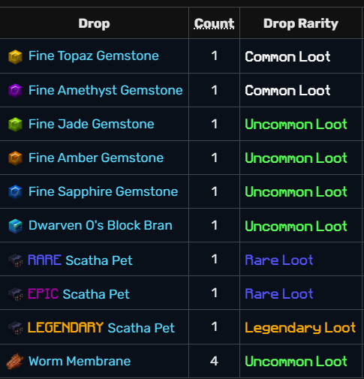
- Vanguard corpses
  - A frozen corpse inside a block of ice that a pickaxe strikes open, after three hits the ice block explodes in smoke and displays the rare drop (most expensive in lowest bin if necessary)
  - Happens with every corpse if the drops are a dud and not in the list below a clown emoji pops up through the smoke
  - Rare drops include
    - Umber key
    - Tungsten key
    - Skeleton key
    - Caged wisp
    - Shattered locket
    - Frostbitten dye
- Mythological ritual
  - The mod includes an animation for these mobs: Sphynx, Inquisitor, King Minos, Manticore
  - Moreover since minos relic drops from minos champion there should be a separate animation for dropping relic
  - The animation for the mobs is their model getting cracked in half and a purple smoke explosion appears displaying the rare drop (only displayed if a rare drop is dropped)
  - Rare drops include
    - Brain food (sphynx head)
    - Chimera I book (Minos inquisitor head)
    - Fateful stinger (manticore head)
    - Manti-core (manticore head)
    - Crown of greed ( king minos head)
    - Shimmering wool (king minos head)
- Dwarven mines ghosts
  - The animation should be displayed in the middle above the inventory hud. The animation should be a charged creaper head and body (no feet) being sliced by a katana revealing the rare drop
  - Rare drops include:
    - Sorrow
    - Plasma
    - Volta
    - Ghostly boots
- Slayers
  - Revenant slayer (zombie)
    - Once killed a big animation displays a zombie hiding in some rose bushes, then a sniper scope pops up and aims at the head, once the bullet fires the screen is covered in green smoke and the smoke slowly disappears displaying the drop
    - Animation only displays only if a drop from the rare drops appears
    - Rare drops include:
      - Severed hand
      - Paragon shard
      - Revenant shard
      - Beheaded horror
      - Scythe blade
      - Shredded sinew
      - Warden heart
      - Matcha dye
  - Tarantula slayer
    - Once killed a big animation displays showing a spider egg being trampled by a steve player model after three jump from steve on the egg then it explodes in white smoke revealing the drop
    - Animation only displays only if a drop from the rare drops appears
    - Rare drops include:
      - Primordial shard
      - Paragon shard
      - Fly swatter
      - Tarantula talisman
      - Vial of venom
      - Shriveled wasp
      - Digested mosquito
      - Ensnared snail
      - Primordial eye
      - Brick red dye
- Reference images
- 